**VISVESVARAYA TECHNOLOGICAL UNIVERSITY**

**“JnanaSangama”, Belgaum -590014, Karnataka.**



**LAB REPORT**

## on

Big Data Analytics

***Submitted by***

## Mohammed Shuraih Shaikh(1BM22CS157)

***in partial fulfillment for the award of the degree of***

**BACHELOR OF ENGINEERING**

***in***

**COMPUTER SCIENCE AND ENGINEERING**



**B.M.S. COLLEGE OF ENGINEERING**

**(Autonomous Institution under VTU)**

**BENGALURU-560019**

## Feb-2024 to July-2024

**B. M. S. College of Engineering,**

**Bull Temple Road, Bangalore 560019**

(Affiliated To Visvesvaraya Technological University, Belgaum)

**Department of Computer Science and Engineering**



### CERTIFICATE

This is to certify that the Lab work entitled “LAB COURSE **Big Data Analytics**” carried out by **Mohammed Shuraih Shaikh(1BM22CS157),** who is a bonafide student of **B. M. S. College of Engineering.** It is in partial fulfillment for the award of **Bachelor of Engineering in Computer Science and Engineering** of the Visvesvaraya Technological University, Belgaum during the year 2024. The Lab report has been approved as it satisfies the academic requirements in respect of a **Big Data Analytics - (23CS6PCBDA)** work prescribed for the said degree.

**Amruta B Dr. Kavitha Sooda**

Assistant Professor Professor and Head

Department of CSE Department of CSE

BMSCE, Bengaluru BMSCE, Bengaluru

# Index Sheet

|  |  |  |
| --- | --- | --- |
| **Sl.**  **No.** | **Experiment Title** | **Page No.** |
| 1 | MongoDB part -1 | 1 |
| 2 | MongoDB part-2 | 5 |
| 3 | Neo4J | 7 |
| 4 | Cassandra part - 1 | 11 |
| 5 | Cassandra part - 2 | 14 |
| 6 | Hadoop | 15 |
| 7 | Word Count using Map Reduce | 18 |
| 8 | Mean Max Temperature using Map Reduce | 20 |
| 9 | Scala & PySpark | 22 |
|  |  |  |
|  |  |  |
|  |  |  |
|  |  |  |
|  |  |  |
|  |  |  |

github link: https://github.com/shuraih776/6thSem-BDA-Lab_1BM22CS157

### Lab 1 MongoDB Part - 1

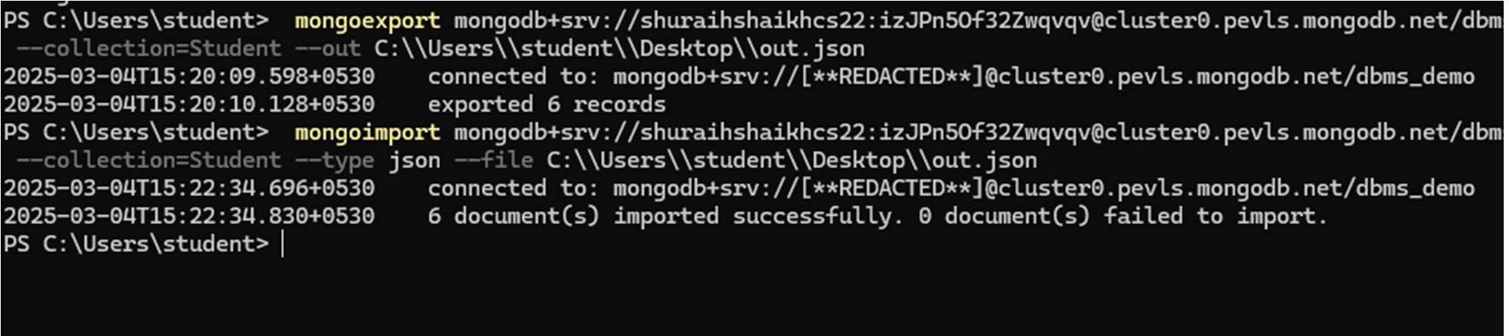

1. **CREATE DATABASE IN MONGODB. use myDB;**

Confirm the existence of your database

**db;**

To list all databases

**show dbs;**

1. **CRUD (CREATE, READ, UPDATE, DELETE) OPERATIONS**
   1. To create a collection by the name “Student”. Let us take a look at the collection list prior to the creation of the new collection “Student”.

**db.createCollection(“Student”);**

* 1. To drop a collection by the name “Student”.

**db.Student.drop();**

* 1. Create a collection by the name “Students” and store the following data in it.

**db.Student.insert({_id:1,StudName:"MichelleJacintha",Grade:"VII",Hobbies:"InternetSurfing"});**

* 1. Insert the document for “AryanDavid” in to the Students collection only if it does not already exist in the collection.

**db.Student.update({_id:3,StudName:"AryanDavid",Grade:"VII"},{$set:{Hobbies:"Skating"}},{upsert:true});**

* 1. FIND METHOD
     1. To search for documents from the “Students” collection based on certain search criteria.

**db.Student.find({StudName:"Aryan David"});**

* + 1. To display only the StudName and Grade from all the documents of the Students collection. The identifier_id should be suppressed and NOT displayed. **db.Student.find({},{StudName:1,Grade:1,_id:0});**
    2. To find those documents where the Grade is set to ‘VII’ **db.Student.find({Grade:{$eq:'VII'}}).pretty();**
    3. To find those documents from the Students collection where the Hobbies is set to either ‘Chess’ or is set to ‘Skating’. **db.Student.find({Hobbies :{ $in: ['Chess','Skating']}}).pretty ();**
    4. To find documents from the Students collection where the StudName begins with “M”.

**db.Student.find({StudName:/^M/}).pretty();**

* + 1. To find documents from the Students collection where the StudNamehas an “e” in any position.

**db.Student.find({StudName:/e/}).pretty();**

* + 1. To find the number of documents in the Students collection.

**db.Student.count();**

* + 1. To sort the documents from the Students collection in the descending order of StudName.

**db.Student.find().sort({StudName:-1}).pretty();**

1. **Import data from a CSV file**

Given a CSV file “sample.txt” in the D:drive, import the file into the MongoDB collection, “SampleJSON”. The collection is in the database “test”.

**mongoimport --db Student --collection airlines --type csv –headerline --file /home/hduser/Desktop/airline.csv**

1. **Export data to a CSV file**

This command used at the command prompt exports MongoDB JSON documents from “Customers” collection in the “test” database into a CSV file “Output.txt” in the D:drive.

**mongoexport --host localhost --db Student --collection airlines --csv --out /home/hduser/Desktop/output.txt – fields “Year”,”Quarter”**

1. **Save Method :**

**Save() method will insert a new document, if the document with the _id does not exist. If it exists it will replace the exisiting document:**

db.Students.save({StudName:”Vamsi”, Grade:”VI”})

1. **Add a new field to existing Document:**

db.Students.update({_id:4},{$set:{Location:”Network”}})

1. **Remove the field in an existing Document**

db.Students.update({_id:4},{$unset:{Location:”Network”}})

1. **Finding Document based on search criteria suppressing few fields**

db.Student.find({_id:1},{StudName:1,Grade:1,_id:0});

**To find those documents where the Grade is not set to ‘VII’**

db.Student.find({Grade:{$ne:'VII'}}).pretty();

**To find documents from the Students collection where the StudName ends with s.**

db.Student.find({StudName:/s$/}).pretty();

1. **to set a particular field value to NULL** db.Students.update({_id:3},{$set:{Location:null}})
2. **Count the number of documents in Student Collections** db.Students.count()
3. **Count the number of documents in Student Collections with grade :VII**

db.Students.count({Grade:”VII”})

**retrieve first 3 documents**

db.Students.find({Grade:”VII”}).limit(3).pretty();

**Sort the document in Ascending order**

db.Students.find().sort({StudName:1}).pretty();

**to Skip the 1st two documents from the Students Collections**

db.Students.find().skip(2).pretty()

1. Create a collection by name “food” and add to each document add a “fruits” array db.food.insert( {

_id:1, fruits:['grapes','mango','apple'] } ) db.food.insert( { _id:2, fruits:['grapes','mango','cherry'] } ) db.food.insert( { _id:3, fruits:['banana','mango'] } )

**To find those documents from the “food” collection which has the “fruits array” constitute of “grapes”, “mango” and “apple”.** db.food.find ( {fruits: ['grapes','mango','apple'] } ). pretty().

**To find in “fruits” array having “mango” in the first index position.**

db.food.find ( {'fruits.1':'grapes'} )

**To find those documents from the “food” collection where the size of the array is two.**

db.food.find ( {“fruits”: {$size:2}} )

**To find the document with a particular id and display the first two elements from the array “fruits”**

db.food.find({_id:1},{“fruits”:{$slice:2}})

**To find all the documets from the food collection which have elements mango and grapes in the array “fruits”**

db.food.find({fruits:{$all:[“mango”,”grapes”]}})

**update on Array:**

**using particular id replace the element present in the 1st index position of the fruits array with apple**

db.food.update({_id:3},{$set:{'fruits.1':'apple'}})

insert new key value pairs in the fruits array db.food.update({_id:2},{$push:{price:{grapes:80,mango:200,cherry:100}}})

**XII. Aggregate Function :**

**Create a collection Customers with fields custID, AcctBal, AcctType.**

**Now group on “custID” and compute the sum of “AccBal”.** db.Customers.aggregate (

{$group : { _id : “$custID”,TotAccBal : {$sum:”$AccBal”} } } );

**match on AcctType:”S” then group on “CustID” and compute the sum of “AccBal”.** db.Customers.aggregate (

{$match:{AcctType:”S”}},{$group : { _id : “$custID”,TotAccBal : {$sum:”$AccBal”} } } );

**match on AcctType:”S” then group on “CustID” and compute the sum of “AccBal” and total balance greater than 1200.**

db.Customers.aggregate ( {$match:{AcctType:”S”}},{$group : { _id : “$custID”,TotAccBal : {$sum:”$AccBal”} } },

{$match:{TotAccBal:{$gt:1200}}});

**Lab 2 MongoDB Part - 2**

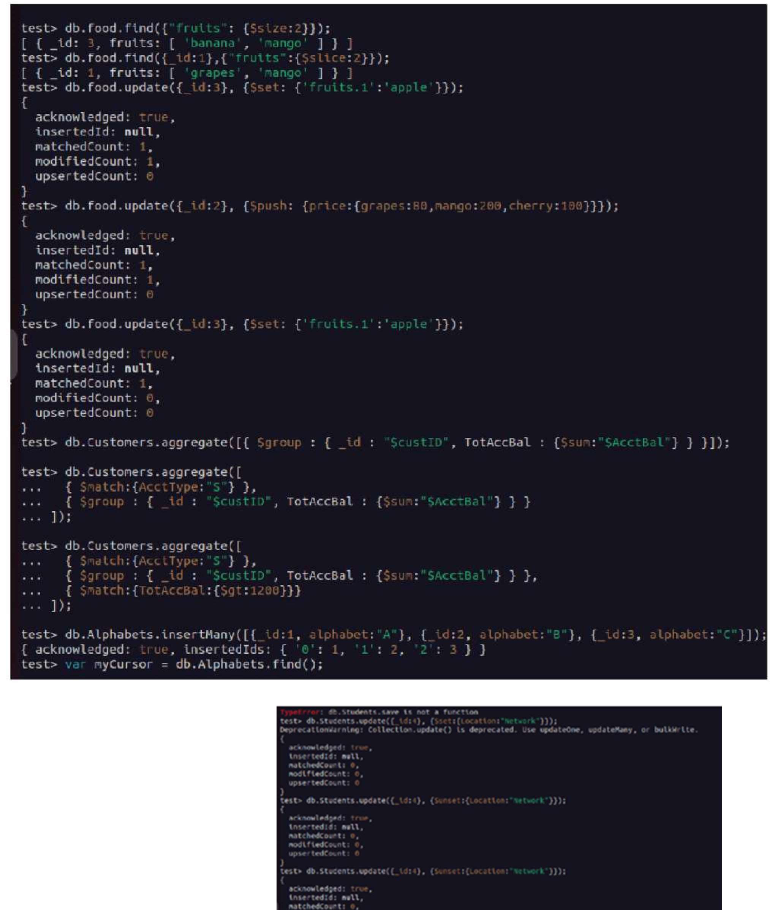

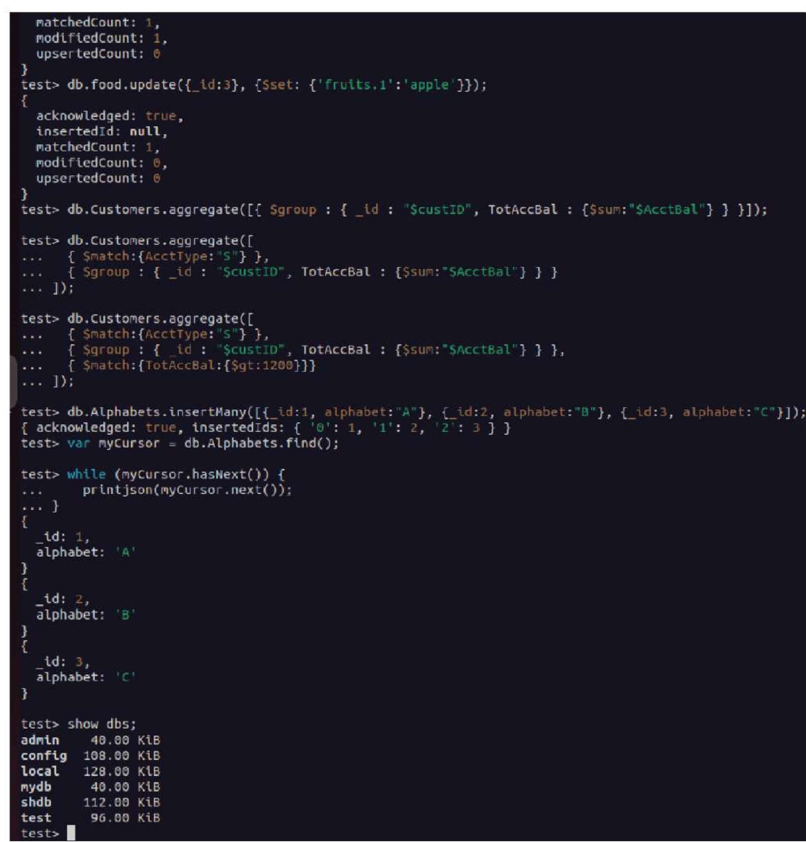

**Lab 3 Neo4J**

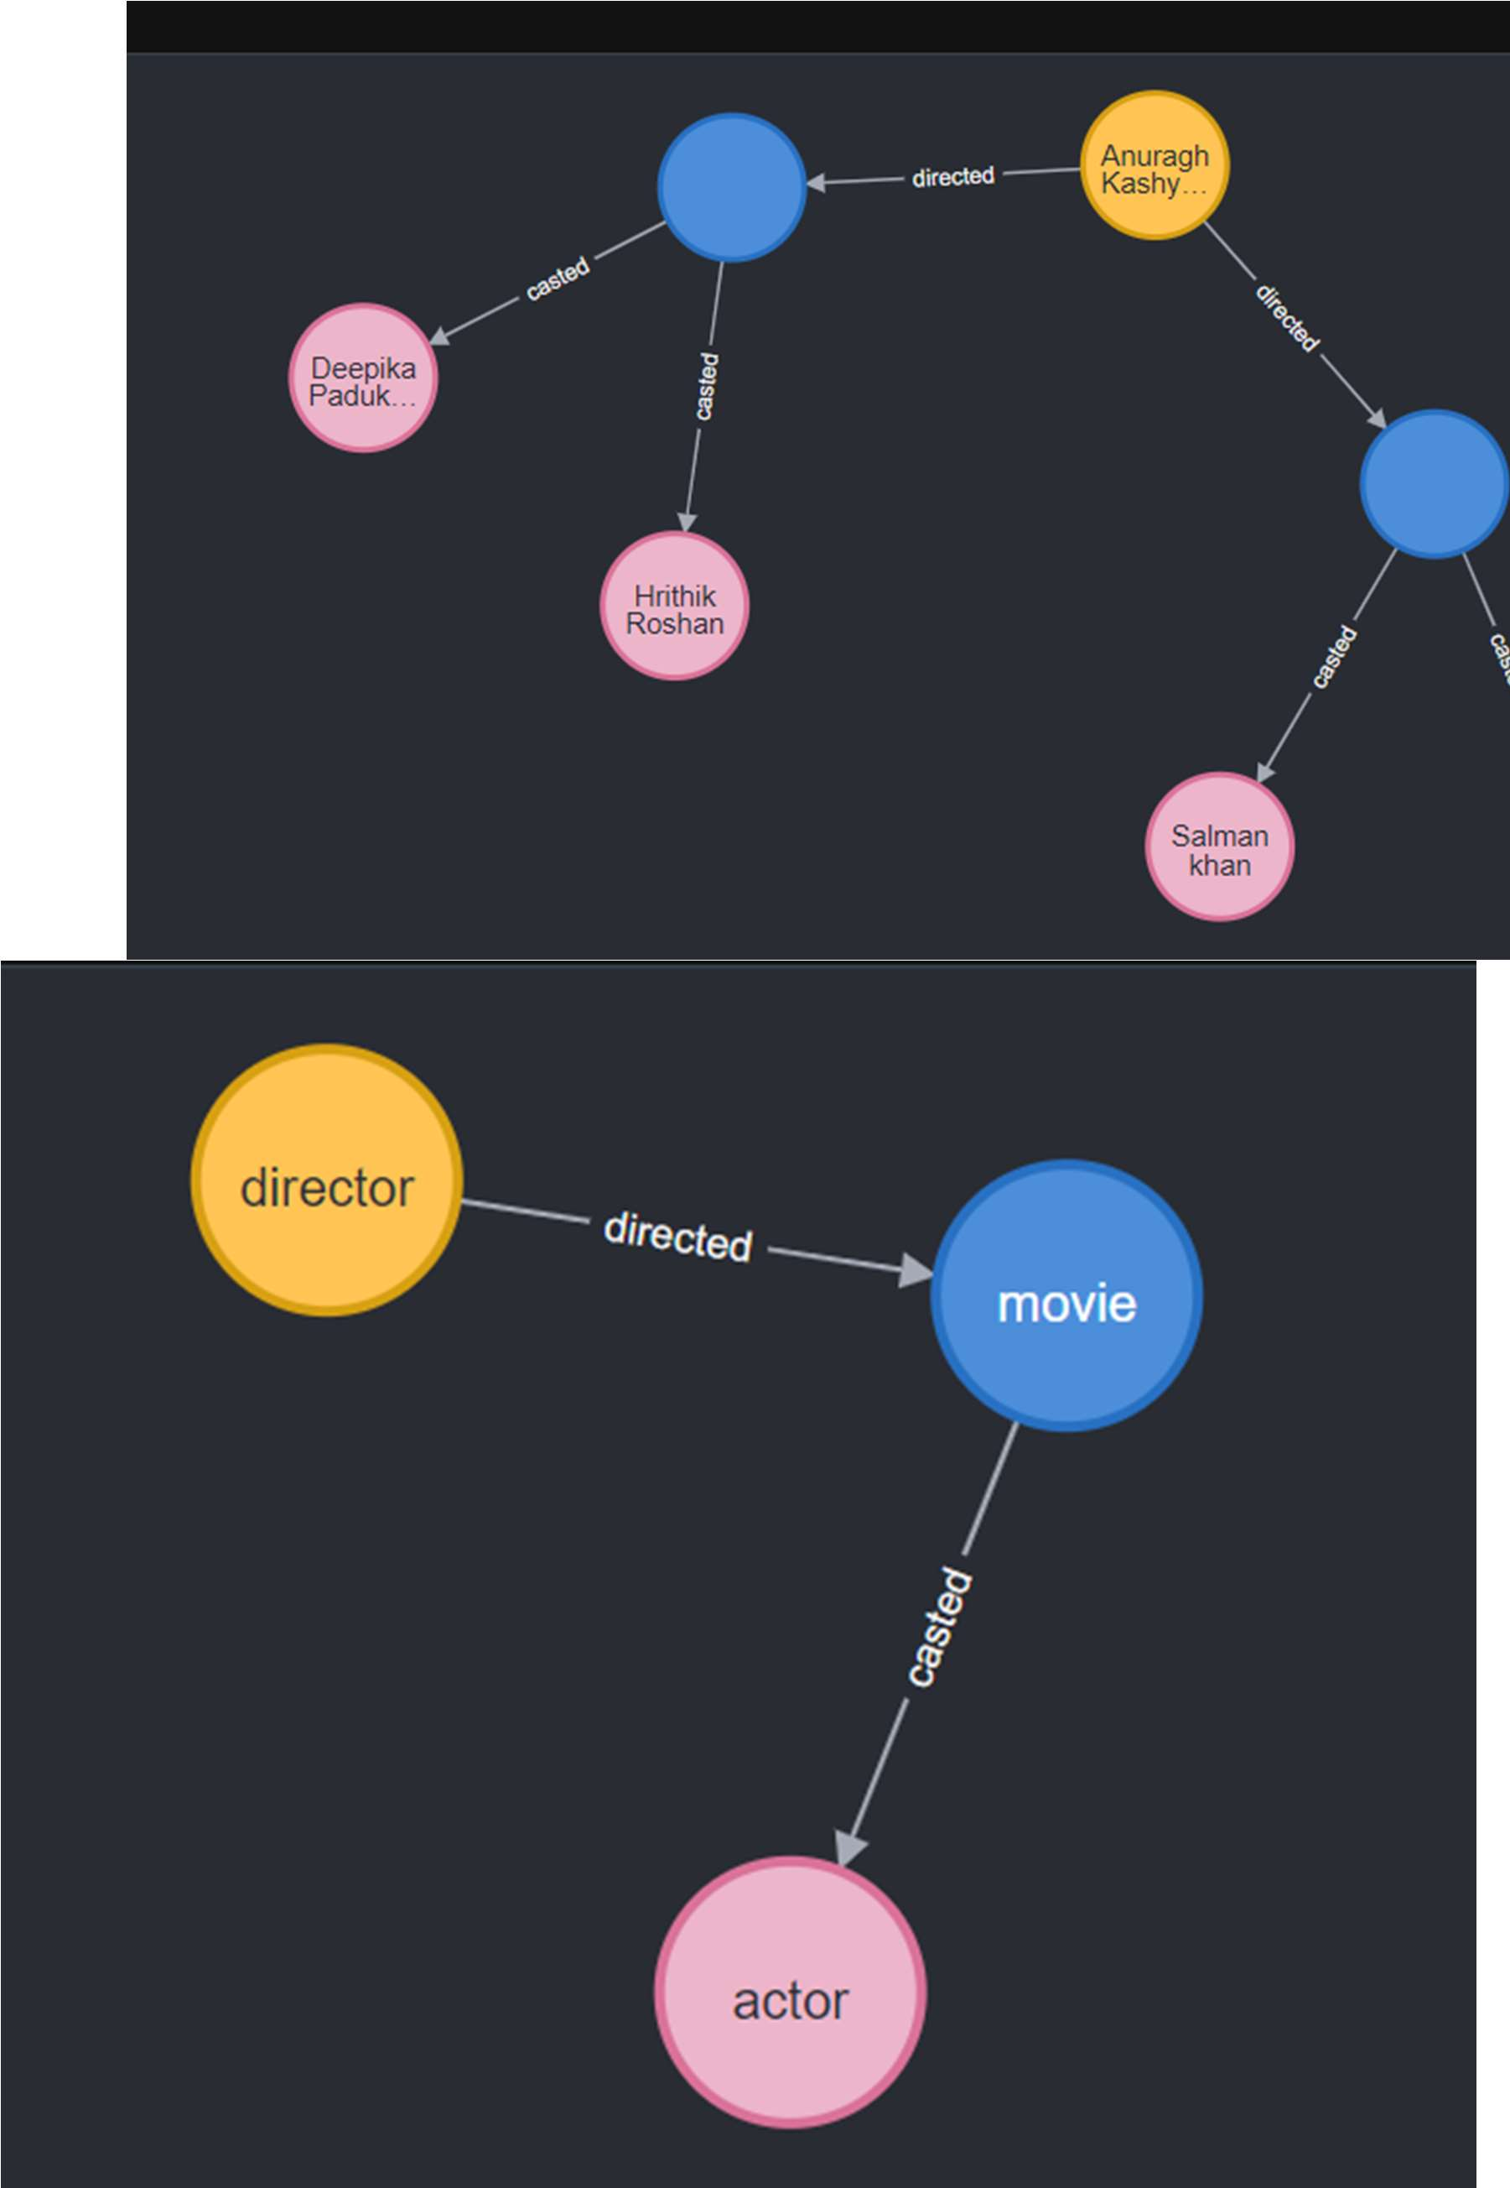

**Lab 4 Cassandra Part - I**

1. What is the command used to create a keyspace named Employee with SimpleStrategy and replication factor 1?

CREATE KEYSPACE Employee

WITH replication = {'class': 'SimpleStrategy', 'replication_factor': 1};

How do you create a table named Employee_Info with fields for ID, name, designation, joining date, salary, and department?

CREATE TABLE Employee_Info ( Emp_Id int PRIMARY KEY, Emp_Name text, Designation text, Date_of_Joining date,

Salary float, Dept_Name text

);

1. How do you insert multiple records in a batch in Cassandra? BEGIN BATCH

INSERT INTO Employee_Info (Emp_Id, Emp_Name, Designation, Date_of_Joining, Salary, Dept_Name)

VALUES (121, 'Anit', 'Manager', '2018-02-01', 70000.0, 'Sales');

INSERT INTO Employee_Info (Emp_Id, Emp_Name, Designation, Date_of_Joining, Salary, Dept_Name)

VALUES (122, 'Priya', 'Developer', '2020-06-15', 50000.0, 'IT');

INSERT INTO Employee_Info (Emp_Id, Emp_Name, Designation, Date_of_Joining, Salary, Dept_Name)

VALUES (123, 'Rahul', 'Analyst', '2019-11-20', 60000.0, 'Finance'); APPLY BATCH;

1. What query updates the name and department of the employee with Emp_Id = 121? UPDATE Employee_Info

SET Emp_Name = 'Anit Kumar', Dept_Name = 'Marketing' WHERE Emp_Id = 121;

1. What is the correct query to fetch employees whose salary is greater than 0 using ALLOW FILTERING?

SELECT * FROM Employee_Info WHERE Salary > 0

ALLOW FILTERING;

1. How do you add a new column Projects of type set<text> to the table? ALTER TABLE Employee_Info ADD Projects set<text>;
2. How do you update the projects of employee with Emp_Id = 121? UPDATE Employee_Info

SET Projects = {'ProjectA', 'ProjectB'} WHERE Emp_Id = 121;

1. How do you insert a new record into the updated table including the new Projects column with TTL?

INSERT INTO Employee_Info (Emp_Id, Emp_Name, Designation, Date_of_Joining, Salary, Dept_Name)

VALUES (124, 'Neha', 'HR', '2022-03-01', 45000.0, 'HR')

USING TTL 15;

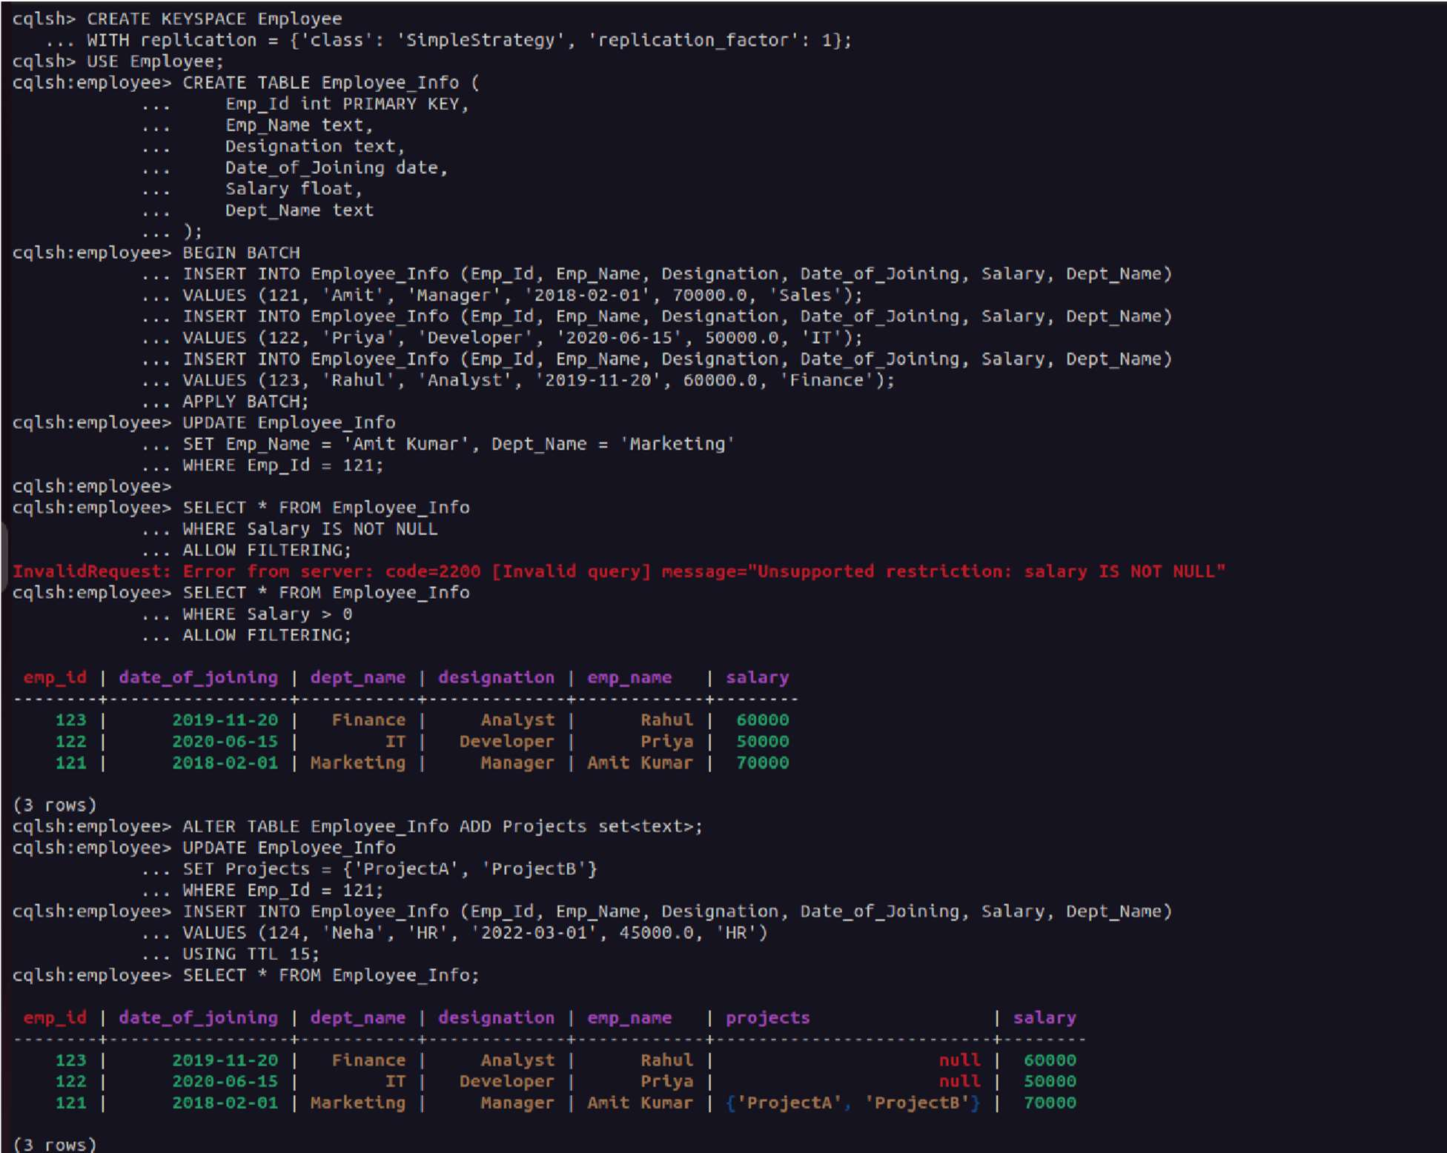

**Lab 5 Cassandra Part - II**

**A. Table: library_student_info B.Table:book_counter_info**

**C. Insert Data in Batch**

You can repeat the UPDATE if you want to increment the counter multiple times. To Simulate Borrowing Book “BDA” 2 Times by Student 112

# Display Table & Increase Counter

Query: Student 112 took “BDA” 2 times

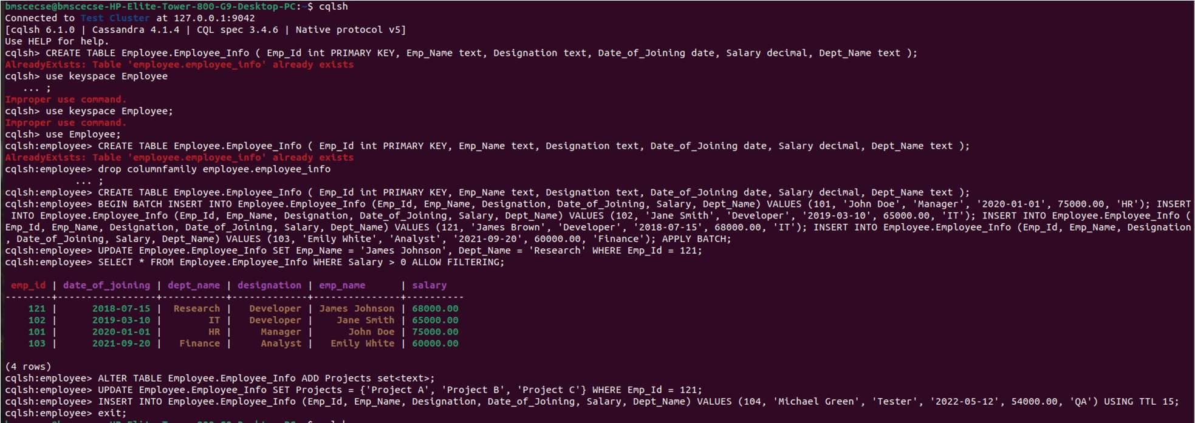

## Lab 6 Hadoop HDFS

### mkdir

**Command:** hdfs dfs -mkdir /abc

**Description:** Creates a directory /abc in HDFS.

### ls

**Command:** hadoop fs -ls /Hadoop

**Description:** Lists contents of the /Hadoop directory with details like permissions, owner, size, and modification date.

### put

**Command:** hdfs dfs -put /home/hduser/Desktop/Welcome.txt /abc/WC.txt

**Description:** Copies Welcome.txt from the local file system to HDFS path /abc/WC.txt.

To view the file contents in HDFS, use:

**Command:** hdfs dfs -cat /abc/WC.txt

### copyFromLocal

**Command:** hdfs dfs -copyFromLocal /home/hduser/Desktop/Welcome.txt /abc/WC.txt

**Description:** Similar to put, but only accepts local file paths as source.

To view the copied file's contents:

**Command:** hdfs dfs -cat /abc/WC2.txt

### get

**Command:** hdfs dfs -get /abc/WC.txt /home/hduser/Downloads/WWC.txt

**Description:** Downloads WC.txt from HDFS to the local path

/home/hduser/Downloads/WWC.txt.

To merge multiple HDFS files into one local file:

**Command:** hdfs dfs -getmerge /abc/WC.txt /abc/WC2.txt /home/hduser/Desktop/Merge.txt

To check ACLs of a directory:

**Command:** hadoop fs -getfacl /abc/

### copyToLocal

**Command:** hdfs dfs -copyToLocal /abc/WC.txt /home/hduser/Desktop

**Description:** Similar to get, but destination must be a local file path.

### cat

**Command:** hdfs dfs -cat /abc/WC.txt

**Description:** Displays the contents of the file WC.txt in the terminal.

### mv

**Command:** hadoop fs -mv /abc /FFF

**Description:** Moves /abc directory in HDFS to /FFF.

### cp

**Command:** hadoop fs -cp /CSE/ /LLL

**Description:** Copies contents from /CSE/ to /LLL within HDFS.

**Screenshots**

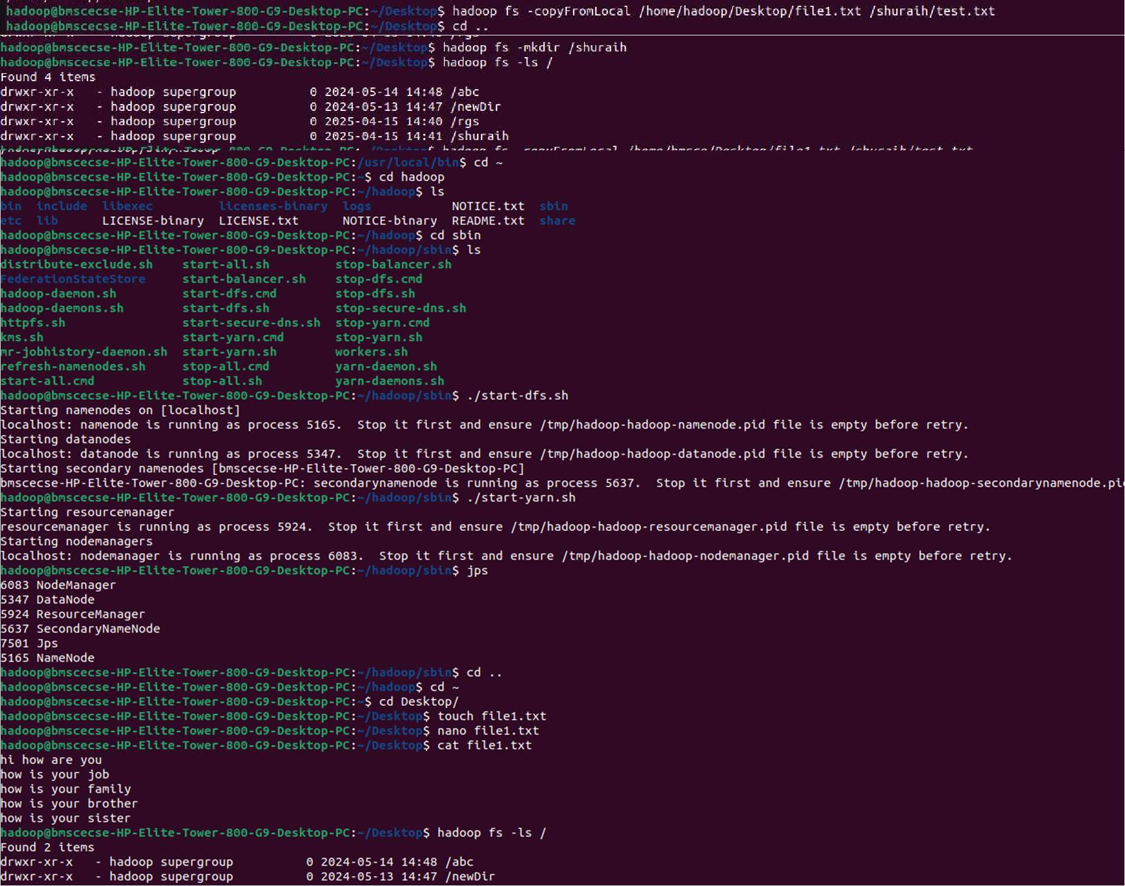

**Lab 7 Word Count using Map-Reduce**

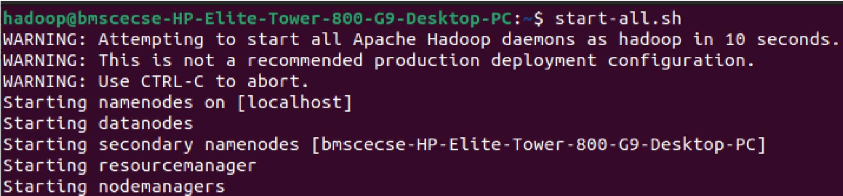

Hadoop services are started using start-all.sh, launching daemons like NameNode, DataNode, and ResourceManager.

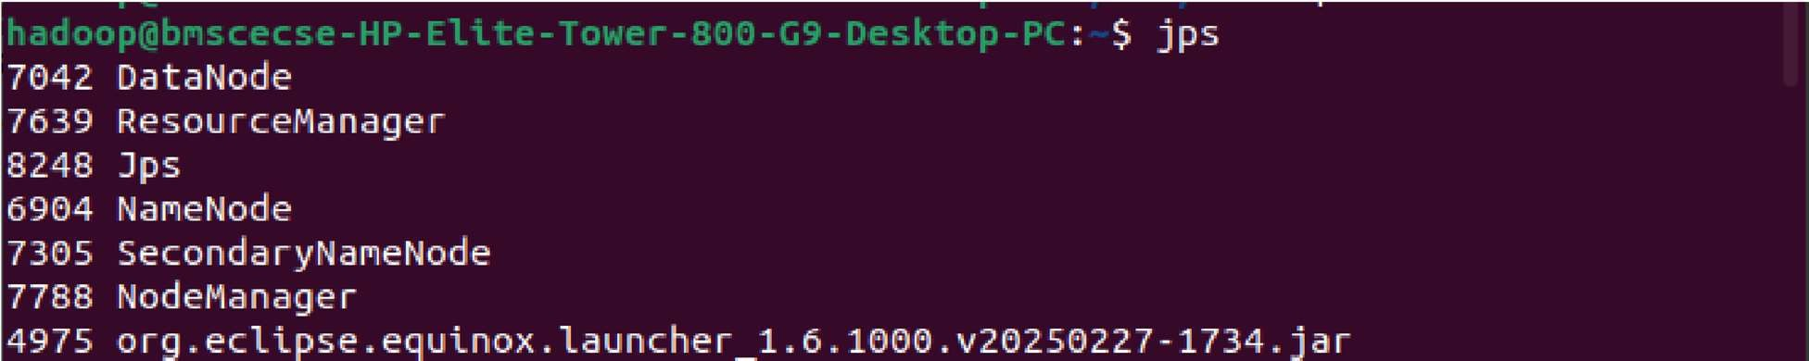

The jps command lists all running Hadoop-related Java processes such as NameNode, DataNode, and ResourceManager.

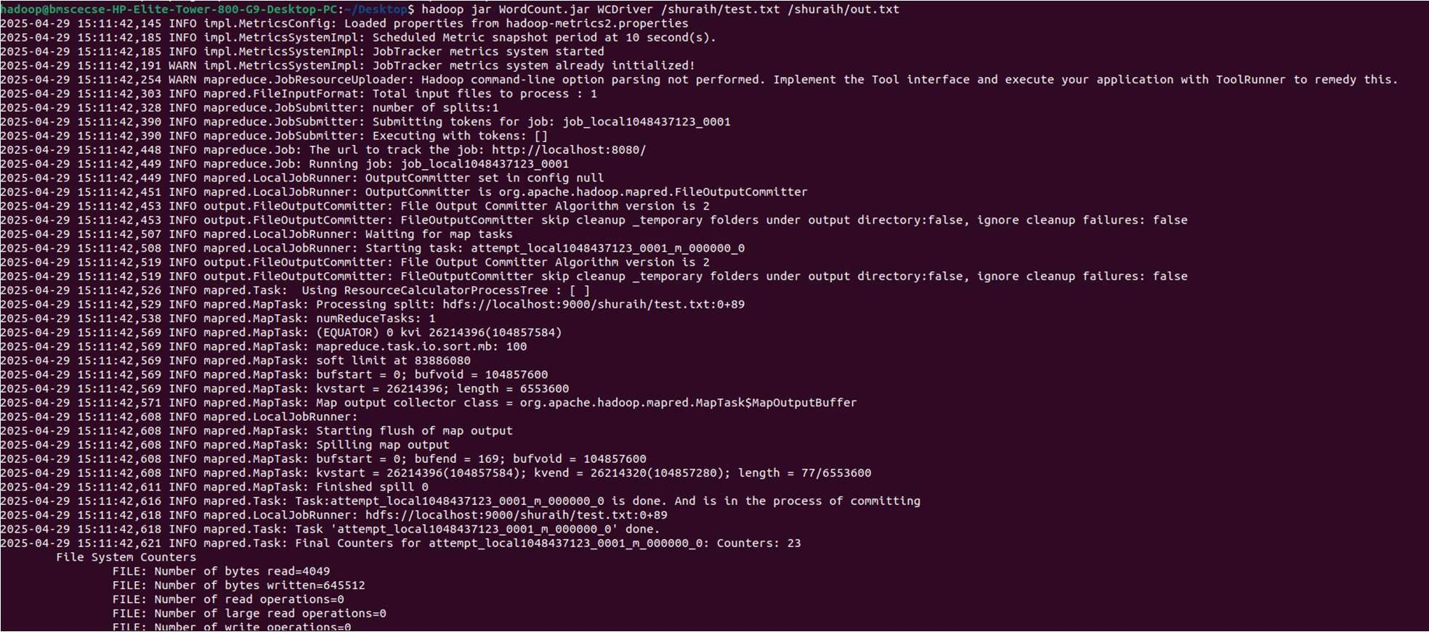

A MapReduce job is executed using hadoop jar to process test.txt and generate output in out.txt.

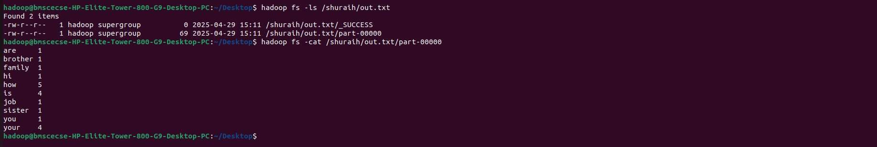

The output of the MapReduce job is displayed using hadoop fs –cat.

**Lab 8 Mean-Max and Avg Temperature using Map-Reduce**

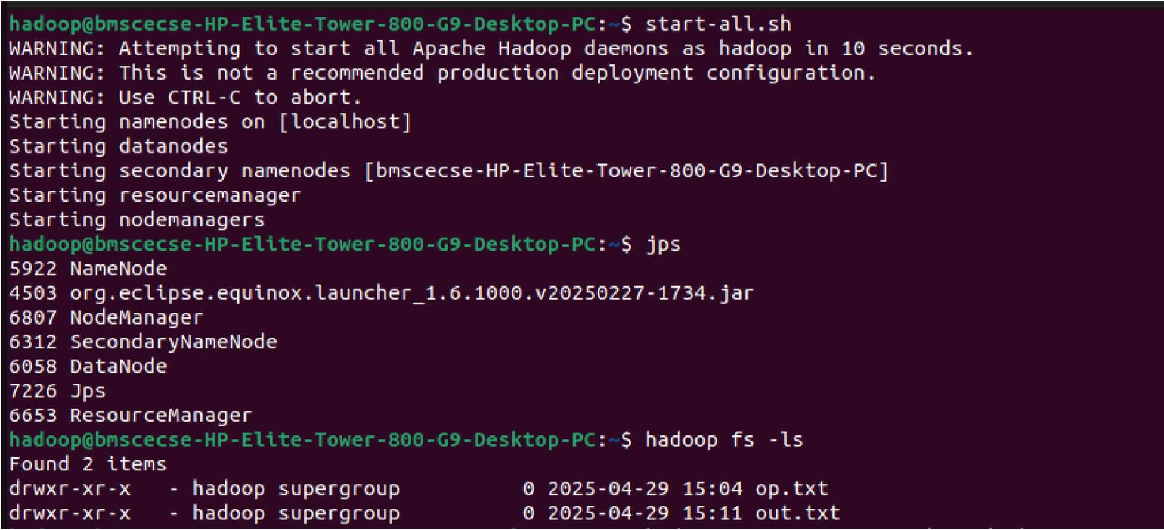

All Hadoop daemons (NameNode, DataNode, etc.) are started using start-all.sh on the local machine.

The jps command confirms active Hadoop services such as NameNode, DataNode, and ResourceManager are running.

The hadoop fs -ls command lists the contents of the HDFS root directory, showing two output folders: op.txt and out.txt.

Average Temperature :

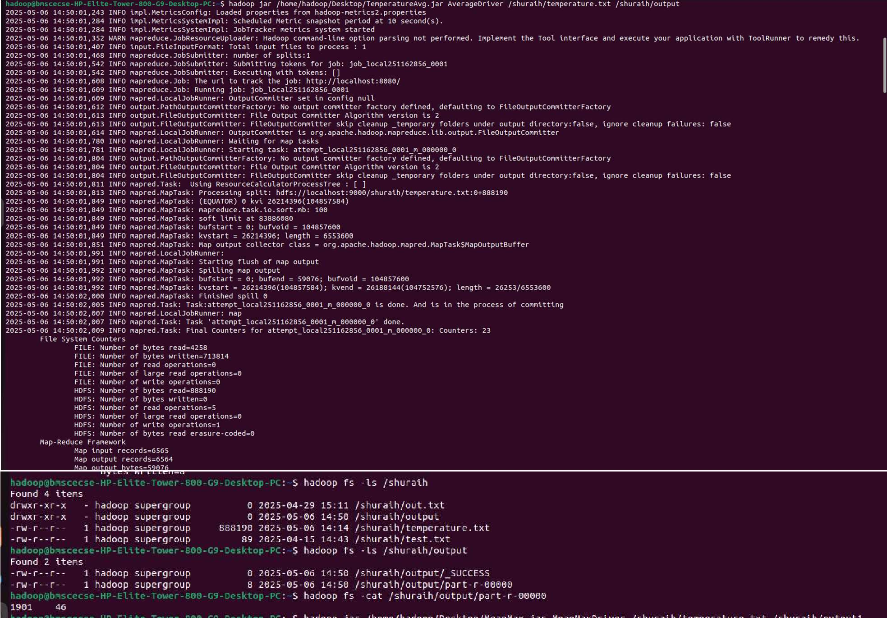

Mean Max Temperature:

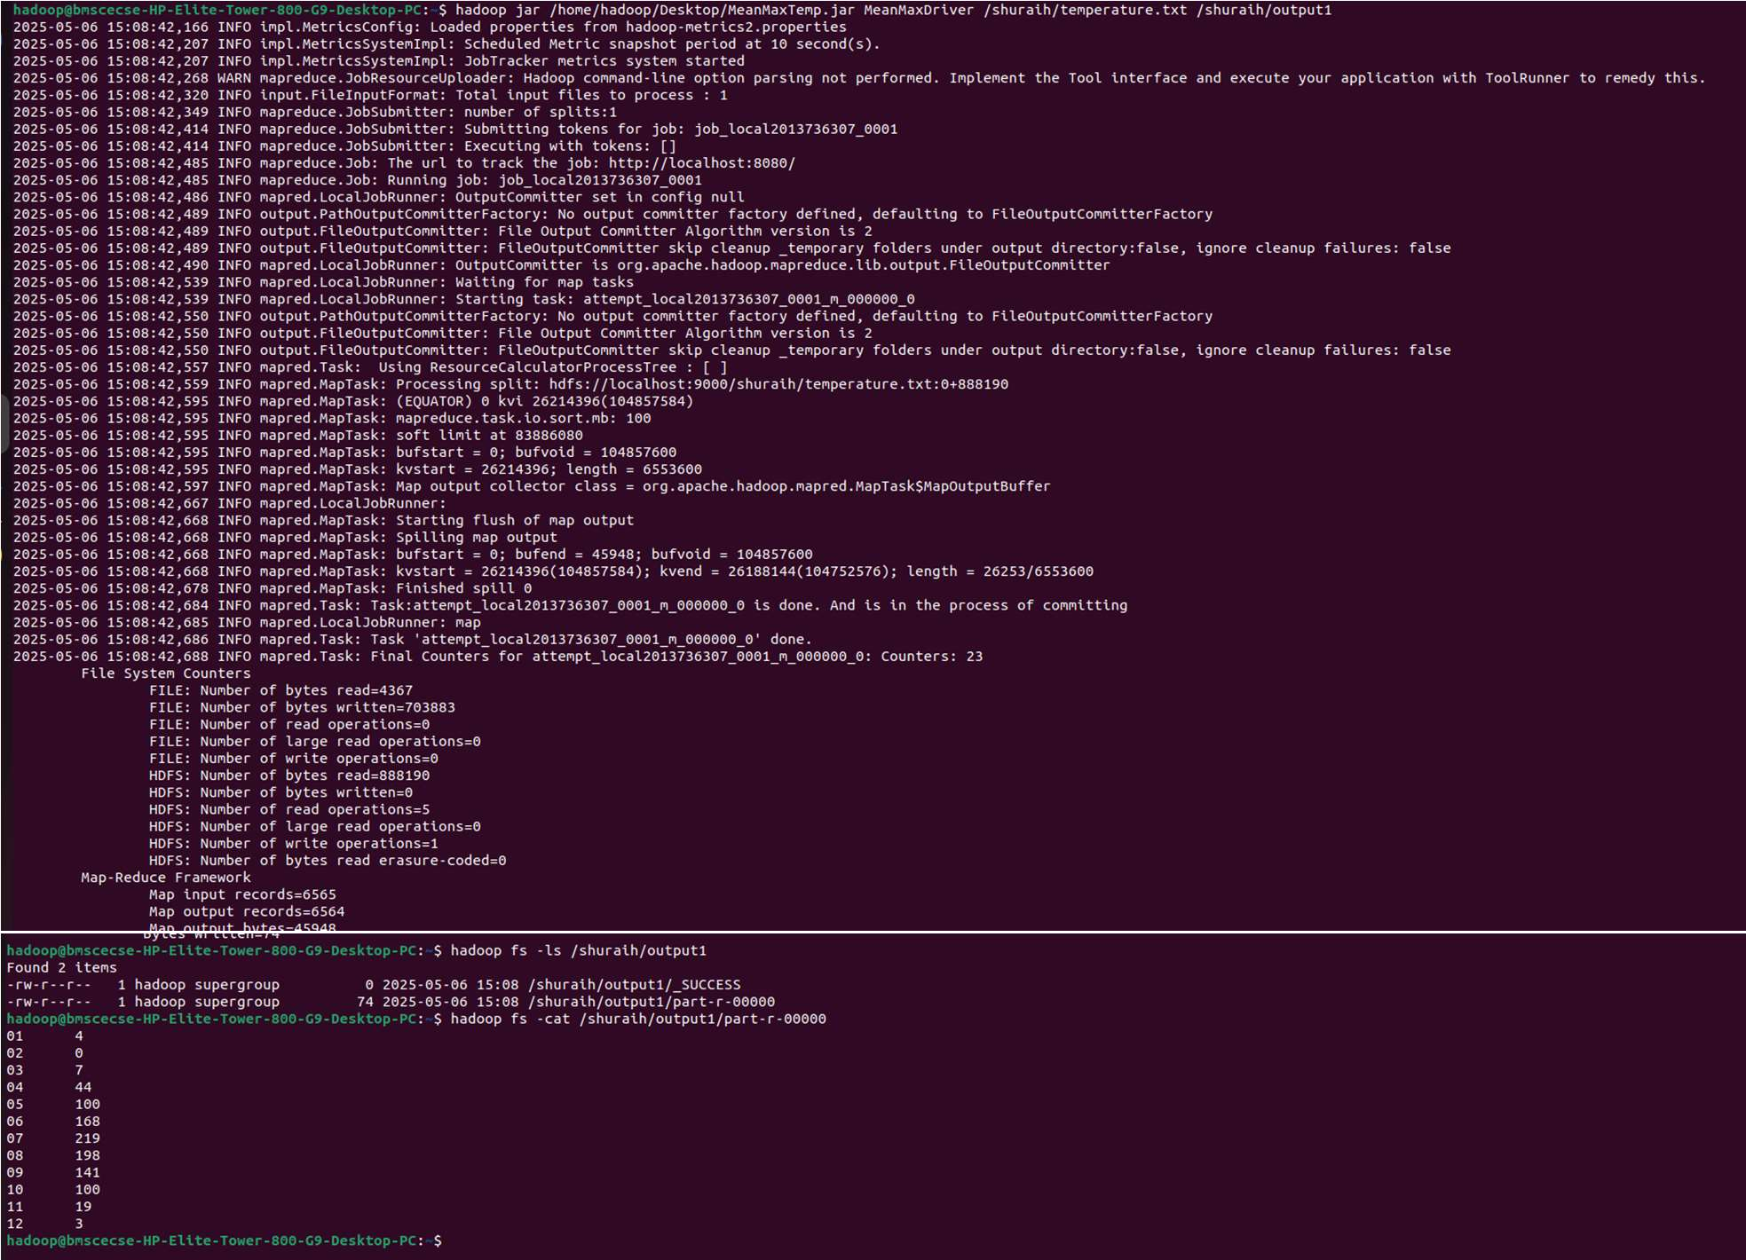

**Lab 9 Scala and pySpark**

1. Write a Scala program to print numbers from 1 to 100 using for loop.

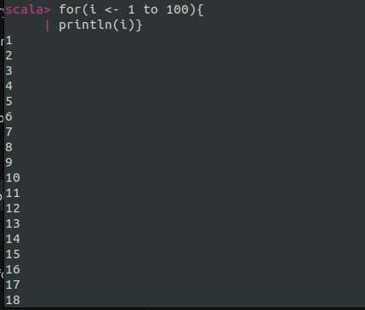

1. Using RDD and FlatMap count how many times each word appears in a file and write out a list of words whose count is strictly greater than 4 using Spark.

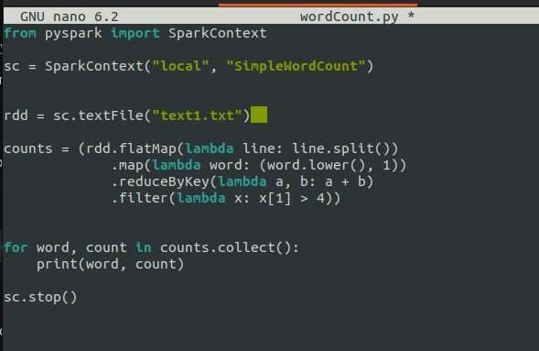

Spark Shell Execution Screenshots

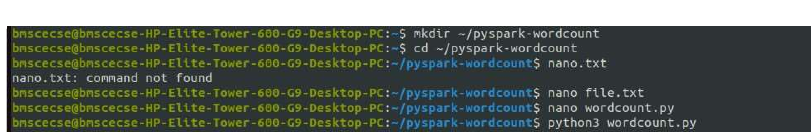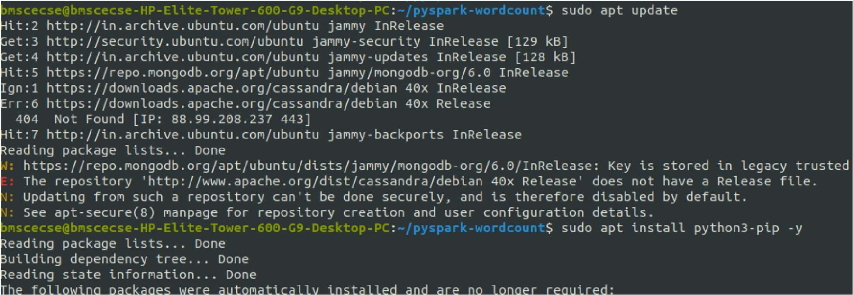

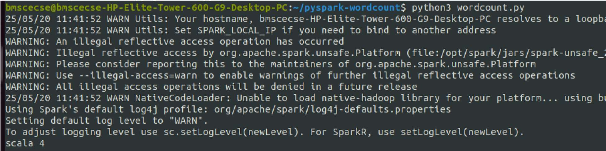

1. 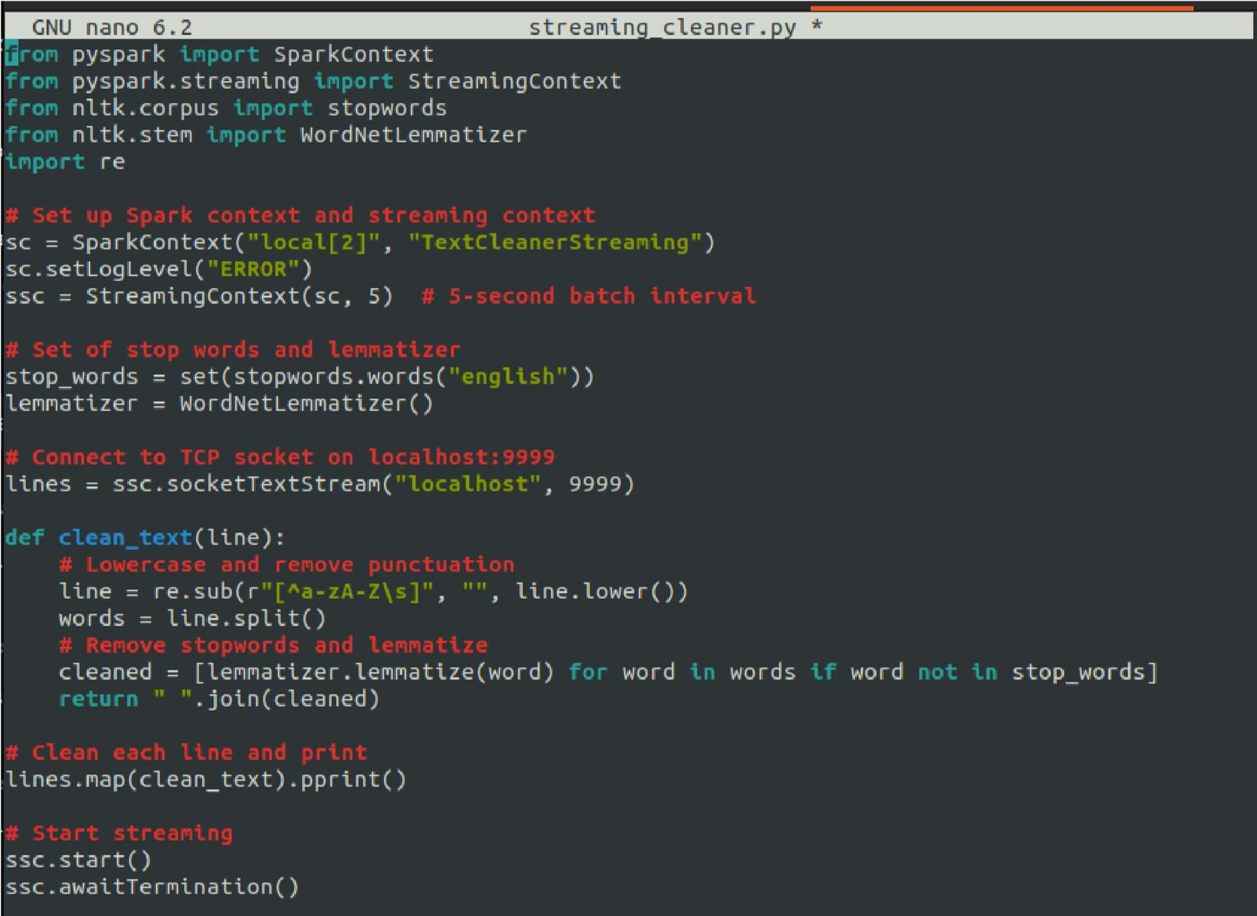Write a simple streaming program in Spark to receive text data streams on a particular port, perform basic text cleaning (like white space removal, stop words removal, lemmatization, etc.), and print the cleaned text on the screen.

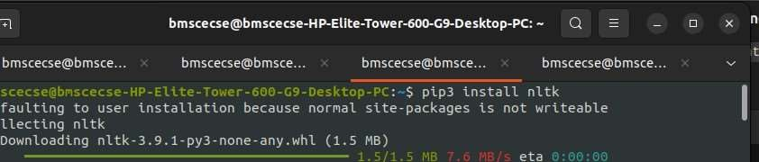

Installation of Natural Language Toolkit (nltk) nlt

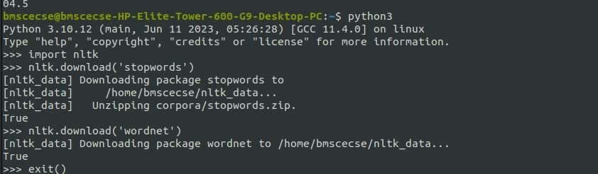

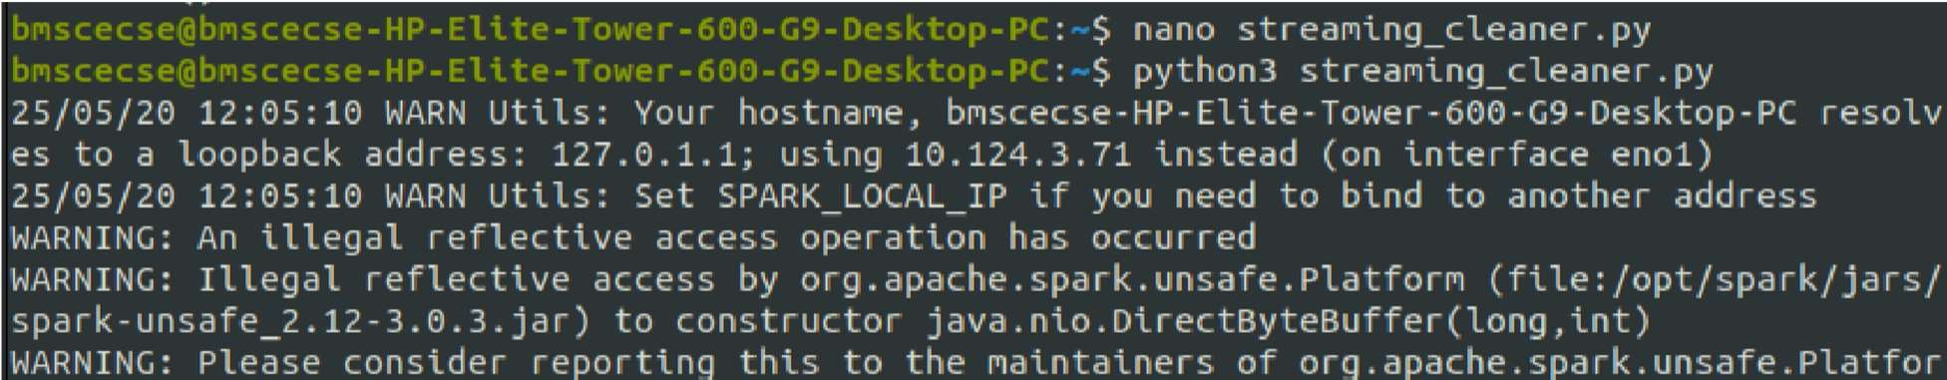

Executing the streaming_cleaner.py

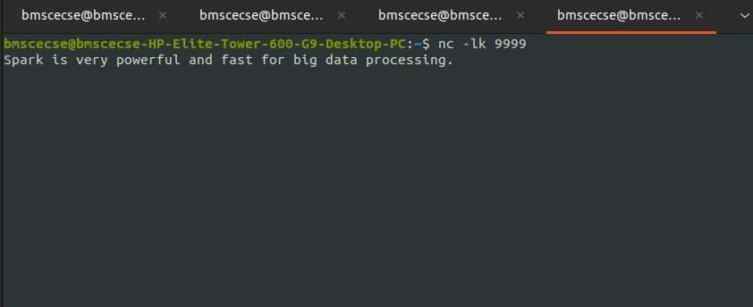

Starting a TCP server that listens for incoming connections on port 9999

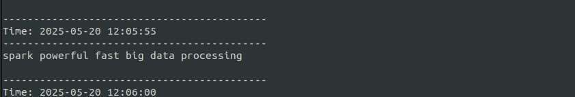

Output- cleaned data